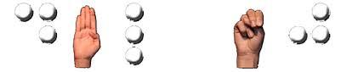DeafBlind League of NJ Membership Form
This membership form is: ☐ New ☐ Renewal
Name:
Address:
Phone:
Email:
Please check all that apply:
☐ Deafblind ☐ Deaf ☐ Hard of Hearing
☐ Blind ☐ Low Vision ☐ Hearing/Sighted
Each year, DBLNJ sends a directory to our members. Please check your contact information you want included in the directory.
☐ Name
☐ Mailing Address
☐ Phone Number
☐ Email Address
How would you like to get your DBLNJ correspondence?
☐ Email
☐ USPS Mail
☐ Braille ☐ contracted ☐ uncontracted
MEMBERSHIP DUES:
There is currently $10.00 fee for membership. To make a donation, go to PayPal.com and send funds to DBL.NJ@aol.com
To complete your membership, either:
- Email this form to Julie Troger, Membership Chair, at: trogfamily@comcast.net
- Send this completed Membership Form to:
Julie Troger, Membership Chair 44 Ravenslake Rd Monroe Township, NJ 08831
- To pay via PayPal, log into your account. Input Sender's address as" DBL.NJ@aol.com " & put your Full Name and Address in the "NOTES" section
THANK YOU FOR YOUR SUPPORT!

